Electron Transport Game

Sponsored by: Dr. Powell and Dr. Shumaker
mpowell@uab.edu, klshumak@uab.edu
Team
ATP and Me
Zakiyyah Harris, Dylan Rohrbach, Gavin Thompson, Ethan Martignoni, Hunter Hogan, Mehak Javed, Naomi Fokkens

Date
4/30/2025
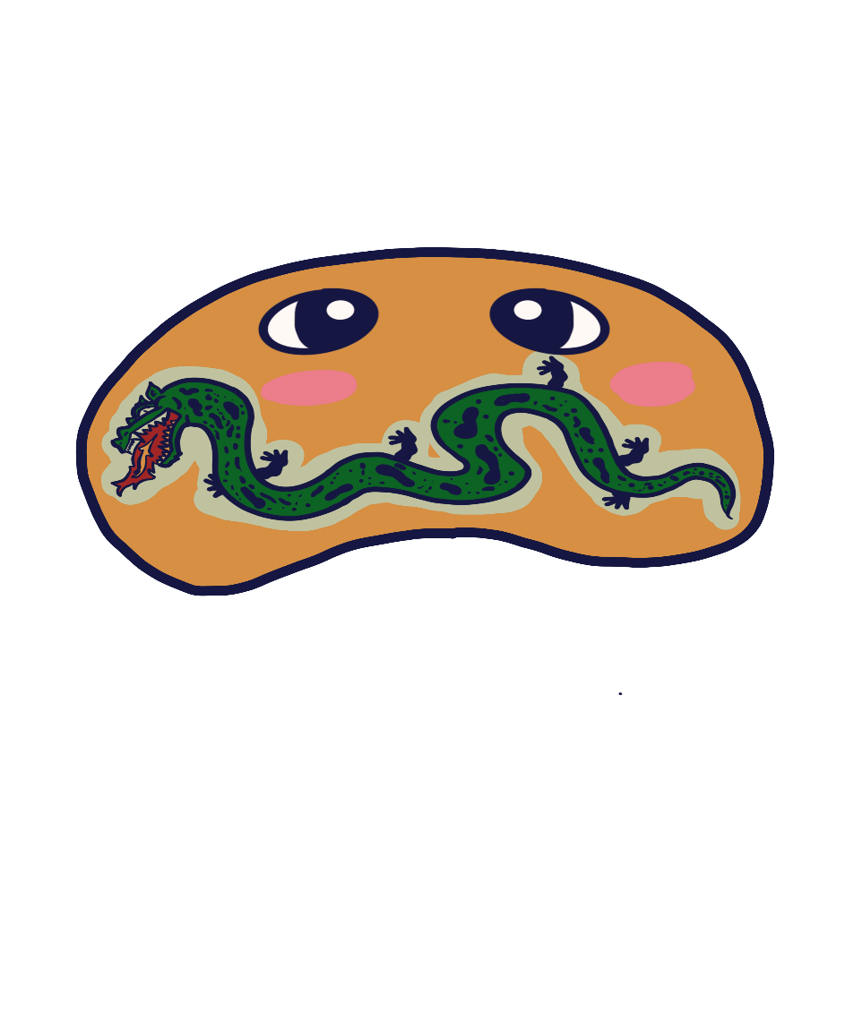

Abstract

The Electron Transport Game was created as an interactive educational tool developed by our team, ATP and Me, for the UAB Biology Department under the guidance of Dr. Powell and Dr. Shumaker. Recognizing that many students struggled to internalize the complex sequence of events that go into creating ATP through oxidative phosphorylation, our team was set out to transform the Electron Transport Chain into an engaging, hands-on experience that would not only teach students the sequence of events but be engaging enough that they would retain the information well after playing it. Built in Godot with a well-developed Python executable application in the backend for Professors themselves to create unique and engaging questions, we created a tool to be packaged and placed within the UAB Biology Lab for students to use and learn the fundamentals of ATP creation. The game’s core deliverable is a guided mode that steps learners through each protein complex, gradient formation, and the ATP synthase activity via a drag-and-drop gameplay loop that gives way to animations of various functions. On a secondary front, we designed both an Unguided and Flashcard mode to be played by students wanting to crack down on their memorization without the need for tutorial, incentivizing speed for better scores that could proudly be displayed in the Biology Lab so students would have a competitive reason to try their hands again and again to learn the game, and with it, how the Electron Transport Chain works. Though the Electron Transport Game is not considered finished as a final product, the steps we’ve taken brought it to an almost finished state with only minor changes left to truly make it perfect for our sponsors.

Table of Contents
Abstract 2
1. Introduction 4
1.1 Motivation/Background 4
1.2 Planned End Product 4
1.3 Current End Product 4
1.4 Explanation of Differences 5
2. Technical Documentation 5
2.1 Software Design 5
2.2 Tools Used 6
2.3 Dependencies/Assumptions 6
3. Evaluation 7
3.1 Test Plan 7
3.2 Testing Conducted 11
3.3 Results of Testing 11
4. Future Work 11
4.1 Where Can the Project Go in the Future? 11
4.2 What Are the Next Steps for This Project’s Development? 12

1. Introduction

1.1 Motivation/Background

The problem found within the UAB Biology Department was something that they had been struggling with for some time now: students were having trouble understanding the Electron Transport Chain due to it being a process of events rather than a ‘one and done’ experience with a lot of other concepts being covered at that time. This struggle caused students to fall behind and their grades to slip, so Dr. Powell and Dr. Shumaker decided to sponsor the CS Department to create a game that they could deliver to their students to help teach this concept in a more engaging manner. Thus, the idea was turned over to our team to make a game based on the above topic.

1.2 Planned End Product

The Electron Transport Game made large strides towards what it initially planned to create. When we first drafted our Proposal, the plan was to create a game with a Guided game mode that would walk students through the material as they played through the game. We specified, if time permitted, that we would additionally work on an Unguided game mode that would challenge students without the tutorial to see if they could properly remember how to create ATP by themselves. It was theorized that we would add an incentive of some form for Unguided mode users so they would come back to the game until they remembered it fully, potentially something given by the professors for whoever did best.

1.3 Current End Product

The current state of The Electron Transport Game turns out to have far succeeded what we believed we would have done come submission time. While there are some hiccups along the way and tweaks that would make the game much better rounded, it currently boasts the features of a custom executable for Professors to implement their own questions into the game for users to be prompted by, a fully animated Guided mode, a complete Unguided mode experience, and a Flashcard mode for those wishing to just study the questions provided by professors. All of this is, additionally, fitted with custom visuals and a new mascot for the game! Guided mode allows for a tutorial approach that students can follow and learn the Chain together with animations and text, Unguided mode gives users a competitive edge in the game to create 3 ATP as fast as possible in order to complete it, and Flashcard mode will prompt users with multiple-choice questions provided by professors in the previous executable so they can study them in a vacuum. We did, however, fail to finish Unguided mode’s intended purpose of having a scoring system with flash cards in-between that gave benefits on right answers and Guided mode does have a hiccup on giving a proper tutorial on how to play and transitions, which would have helped the flow of the game.

1.4 Explanation of Differences

As mentioned before in 1.2 and 1.3, we have had some massive changes like new modes, a mascot, and a new executable. We were, however, unable to complete Unguided mode within the vision of what we wanted. While there is a complete game loop, it does not have the competitive incentive nor the flashcard mechanic that was initially set into plan when making it. A big part of this issue came down to two issues: One was the need to learn multiple new technologies to begin creating the game and the second issue was the need to learn what we would be teaching other people. When creating a game meant to teach other people, we quickly realized that the team needed to deeply understand the topic in order to properly distribute that information to another party, which meant a lot of research needed to be done on both our new technologies like Godot and Aseprite as well as the research into the topic itself on an educator’s level. There was also a lack of emphasis on workload distribution, which meant the initial weeks fell behind before productivity began to fully maximize. For all these reasons, a better strategy would have been to properly introduce Agile workflow into our work methodology.

2. Technical Documentation

2.1 Software Design

The Electron Transport Game employs modular, scene-by-scene based architecture built on the Godot Engine to maximize maintainability, scalability, and cross-platform portability. The core gameplay logic uses drag-and-drop puzzles, guided tutorial flow, quiz interactions, and feedback animations were implemented in GDScript, with each major feature encapsulated in its own scene or set of scenes and scripts for clear separation. UI components are defined in reusable node hierarchies and communicate with the game’s logic using the built-in Godot signaling system, enabling decoupled event handling. The only thing build outside of Godot is the unique Python executable and .Json file meant for both creating and holding quiz questions that can be managed in an easy to use and modify format by professors.

2.2 Tools Used

- Godot 4: Our core game engine for scene management, 2D rendering, input handling, and exporting. All the logic, UI Screens, levels, and animations were built within Godot using its robust node system and GDScript
- Python: A standalone Python executable was created with the purpose of allowing professors to create, manage, and modify questions at their leisure to be implemented within the Godot game.
- Tkinter: Tkinter was used to create appealing visuals and tooltips to help guide professors when using the Python executable so they would know what to do in order to make their questions.
- Pyinstaller: Pyinstaller was used to package together the python application so it could be ran as a packaged app for professors.
- Aseprite: Asesprite was used to create the entirety of the art used within the game, with an emphasis on the pixelated designs that is best made using the tool.
- JSON: JSON was used as our lightweight data format for storing quiz questions, answer choices, and information pertaining to any questions created by the professors when they wanted to use the Python application.

2.3 Dependencies/Assumptions

Dependencies:
- Godot Engine: The game’s core runtime and editor.
- Python: Required for editing and maintaining the question-bank tool
- Tkinter: GUI provided to the Python application
- PyInstaller: Packages for the Python tool into an executable for ease of distribution.
- JSON Parsing Libraries: Godot has one built in at runtime, otherwise it is needed as a standard Json module in Python.
- Aseprite Assets: All sprite sheets and objects authored within Aseprite and exported into the art pipeline.

Assumptions:
- Compatible desktop OS: It is assumed that the professors and laptops can accurately open and play the executables.
- Local-Only Gameplay: It is assumed that users will not attempt to upload data to a server, as the game is fully offline.
- Hardware Minimums: It is assumed the lab devices have hardware capabilities of running the application with no issue
- Data Integrity: it is assumed that professors and students will not attempt to modify the JSON file directly.
- Biology Student: It is assumed that most players wanting to set scores and play the game are students currently taking the UAB biology course and have a general understanding of basic biology structures.

3. Evaluation

3.1 Test Plan

1. System Feature: Quiz Questions
Description:
A user is either using the flashcard game mode or is using the Unguided mode and an internal timer has counted down to zero. Upon these triggers, the user is shown a multiple-choice question in which they must click an answer. Feedback is given to the user depending on their choice.

Requirements
REQ-1: Allow users to answer quiz questions.
REQ-2: Implementing answers to questions that are revealed after answering questions.

Feature | Test Value | Expected Result
Quiz Question Appears | Appearance | The game pauses if it is in Unguided.
Quiz Answer | Answer Correct | The mascot duck shows a happy face, the right answer (yours) is highlighted in green.
 | Answer Incorrect | The mascot duck shows a sad face, the right answer is highlighted in green, and your incorrect answer is highlighted in red.

2. System Feature: Drag and Drop Design For Puzzles

Description:
This feature allows users to grab items in the game and ‘drag’ them with their mouse to complete puzzles by taking the objects to the correct places to process through the game.

Requirements:
REQ-1: Allow user to drag and drop items.
REQ-2: Implement the drag and drop.

Test Values | Expected Result
User Clicks a Draggable Object | The object is brought to the mouse cursor
User clicks a non-draggable object | Nothing happens
User drags an object | The object follows the mouse
User lets go of an object on top of the right zone | The correct animation plays or a tween effect plays depending on game mode.
User lets go of an object on top of an incorrect zone | Nothing happens, the object is set down

3. System Feature: Animations
Description:
This feature will move the objects on screen to show the process of what actions the user is currently inputting within the game.

Requirements:
REQ-1: Provide Feedback to the user’s choices

Test Values | Expected Result
User drops an object in the correct zone in Guided Mode | The corresponding animation plays in accordance to the level they are on
User drops an object in the correct zone ins Unguided Mode | The object plays their corresponding tween effect
User clicks a correct choice in Flashcard mode | The duck mascot plays a happy animation
User clicks an incorrect choice in Flashcard mode | The dusk mascot plays an unhappy animation
User reaches the end of Guided or Unguided | A small looping animation is played on a victory screen

4. System Feature: Object Classes for Game Items
Description:
The items in the game will belong to unique classes that will have different functionality. Molecules spawn in for the user to drag into the correct protein complex. These molecules will split into electrons, protons, and left over elements. An object class for electron holders such as CoEQ10 and CytC. Finally, an object representing the ATP.

Requirements:
REQ-1: A user must be able to drag and drop the objects.
REQ-2: An invalid input, such as dragging the FADH2 object into protein complex I, will do nothing.

Test Cases | Expected Result
NADH is dragged on Complex I | Positive feedback Animation Plays
NADH is dragged onto any other complex | Nothing Happens
FADH2 is dragged on Complex I | Positive feedback Animation Plays
FADH2 is dragged on any other Complex | Nothing happens
CoQ is dragged onto Complex III | Positive feedback Animation plays
CoQ is dragged onto a Complex or object that isn’t Complex III | Nothing Happens
CytC is dragged onto a Complex that isn’t Complex IV | Nothing Happens
CytC is dragged onto a complex IV | Positive feedback Animation Plays
Protons, Electrons, and Oxygen elements are not dragged into their correct zones | Nothing happens
Protons, Electrons, and Oxygen elements are dragged into their correct zones | Positive feedback Animation plays

5. System Feature: Main Menu
Description:
This feature will give users the functional ability to play the game, quit, or change their game mode.

Requirements:
REQ-1: Allows users to choose their game mode.
REQ-2: Implement the ability to play the game over from the start, initializing new values to begin teaching again.

Test Values | Expected Result
Play Button Clicked | User is brought to the Game Mode menu
Quit Button Clicked | The application is closed
Game Mode Buttons Clicked | The chosen Game Mode button is highlighted as their choice
Game Mode Menu Button Clicked | User is brought back to the first menu
Game Mode Play Button Clicked when Game Mode Selected | User is taken to play their chosen Game Mode type
Game Mode Play Button Clicked when Game Mode not Selected | Nothing Happens and the button is non-interactable

6. System Feature: Python Executable
Description:
This feature is a separate standalone that professors are allowed to use to change questions within an application that will be transmitted to the Godot game for students to be quizzed on.

Requirements:
REQ-1: Professors must be able to open, use, and operate the application.
REQ-2: The changes made within the application are brought automatically to the Godot game to be used.

Test Values | Expected Result
Professor Clicks on the Application | The Application Opens
Professor clicks Previous Or Next Buttons | The application scrolls through the various Quiz questions
Professor clicks Previous or Next Buttons when there are no questions left on either side | A popup appears to explain that there are no more questions left to scroll through in that direction.
Professor Clicks Add New Button | A new entry is created for the professor to fill out.
Professor Clicks Remove Button | The current question is deleted
Professor Clicks Save Button | All changes made are saved to the JSON file
Professor fills out Entry Fields | The text they type is shown on screen in the correct fields
Professor Does not fill out Entry Fields/Incorrectly fills them out and Saves | The information is successfully put into the JSON, but can be removed
Professor closes application without saving | The recently input data of that session is lost
Professor hovers their mouse over entry fields or buttons | A tooltip pops up after a delay to explain the functionality

3.2 Testing Conducted

Extensive testing was done on all fronts by repeatedly playing through the game on multiple different devices by multiple different people. Each time someone went through the game, any errors were given to the team which were then considered for fixing. The Python Application was thoroughly tested with different values, inputs, and mistakes to handle the capabilities of the product to make sure it wouldn’t cause issues for the professors. We don’t have any automatic testing, so everything was done manually by the creators of the application and any friends they were able to hand the application to. Testing consisted of:
- Playing the Game through each game mode
- Dragging the objects to various locations
- Attempting to sequence break Guided and Unguided Mode
- Answering questions correctly and incorrectly when presented with them
- Trying to drag objects off the screen on single-screen laptops
- Trying to lose objects by placing other objects on top of them.

3.3 Results of Testing

The results we were constantly given tended to give unique bugs that required new looks into the various scripts being made to ensure that the particular issue or bug could not be replicated again. This, of course, meant that bugs would appear as more testing and features were added to the game. Since this was a constant loop of fixing bugs to create more bugs later on, the team was tasked with constantly checking and playing the game in order to understand what was creating which issue. Most bugs are a result of GDScript, meaning that all of them could eventually be fixed within Godot so long as enough time permitted. While there are still many bugs to fix, we hope to fix them in the future to satisfy our sponsors.

4. Future Work

4.1 Where Can the Project Go in the Future?

Potential Advancements:
- Bug Fixes: The game still has many bugs within it that can cause the game to not work properly
- Leaderboard: The game still needs the leaderboard functionality to be built in.
- Scoring System: Unguided mode still needs to get a proper scoring system and UI for students to track progress.
- Flashcard Implementation: Unguided mode currently does not have the intended flash cards meant to come with the game mode.
- Scene Transitions: Guided mode would have a better flow if there was a smoother transition from scene to scene, perhaps even with text explaining what would happen next.
- Lockout/Key: The Python Application can be modified by anyone who opens it on that device. It would potentially be best if we asked for a key given to professors so students could not try to inflate their scores.

4.2 What Are the Next Steps for This Project’s Development?

- Major bug fixing.
- Integrate the flash cards into unguided and upgrade the scoring system accordingly.

